Name :- Pralay K Kalaskar

Mail :- ([pkkdkalaskar71@gmail.com](mailto:pkkdkalaskar71@gmail.com))

Phone :- +91-7066216365

Linkedin :- [www.linkedin.com/in/pralay-kalaskar-1010](http://www.linkedin.com/in/pralay-kalaskar-1010)

SQL Assignment_Part1 - SET 1

Starts Here :- P.T.O.



SET 1

------

1. create a database called **'assignment'** (Note please do the assignment tasks in this database)

**Answer :-**

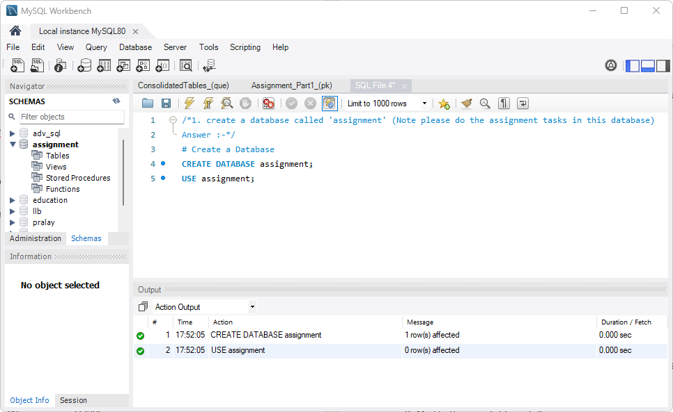

2. Create the tables from ConsolidatedTables.sql and enter the records as specified in it.

**Answer :-**

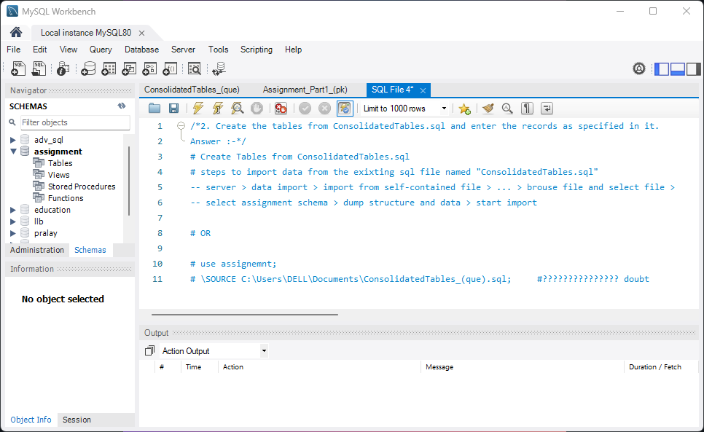

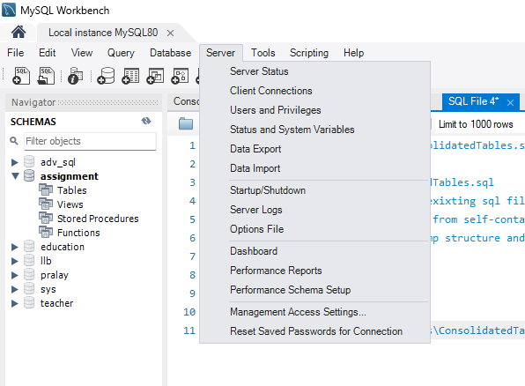

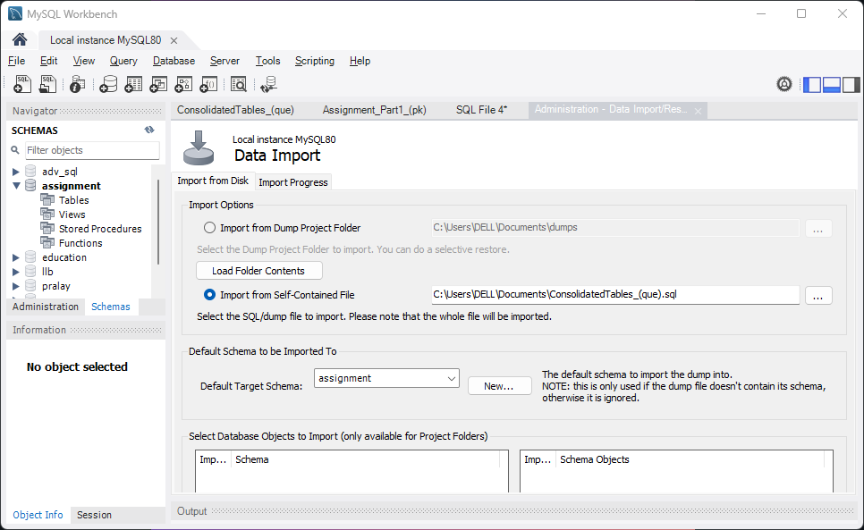

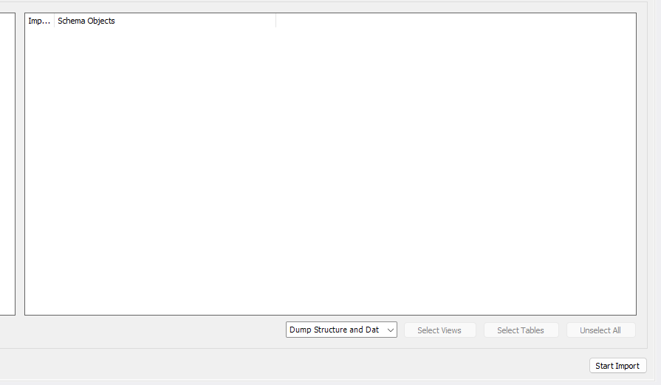

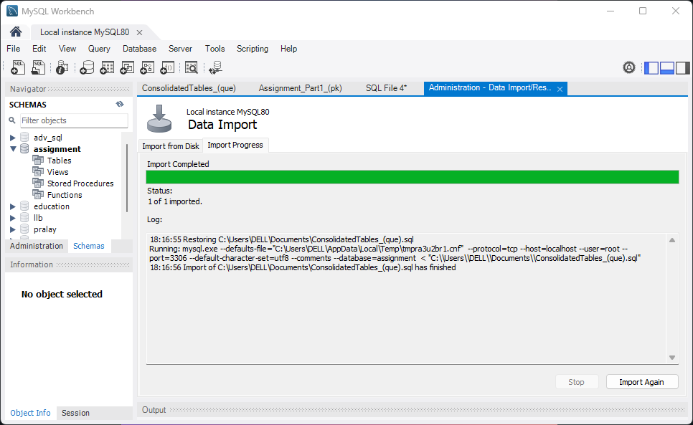

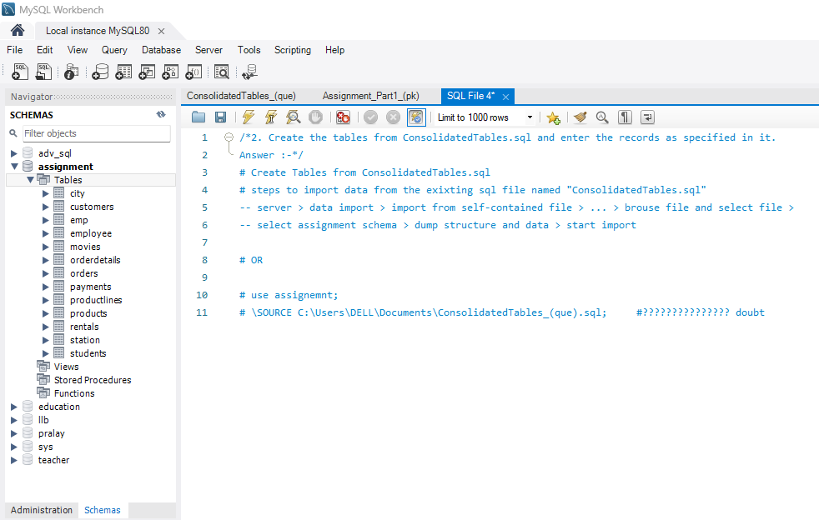

3. Create a table called **countries** with the following columns

***name, population, capital***

- choose appropriate datatypes for the columns

a) Insert the following data into the table

China 1382 Beijing

India 1326 Delhi

United States 324 Washington D.C.

Indonesia 260 Jakarta

Brazil 209 Brasilia

Pakistan 193 Islamabad

Nigeria 187 Abuja

Bangladesh 163 Dhaka

Russia 143 Moscow

Mexico 128 Mexico City

Japan 126 Tokyo

Philippines 102 Manila

Ethiopia 101 Addis Ababa

Vietnam 94 Hanoi

Egypt 93 Cairo

Germany 81 Berlin

Iran 80 Tehran

Turkey 79 Ankara

Congo 79 Kinshasa

France 64 Paris

United Kingdom 65 London

Italy 60 Rome

South Africa 55 Pretoria

Myanmar 54 Naypyidaw

b) Add a couple of countries of your choice

c) Change ‘Delhi' to ‘New Delhi'

**Answer :-**

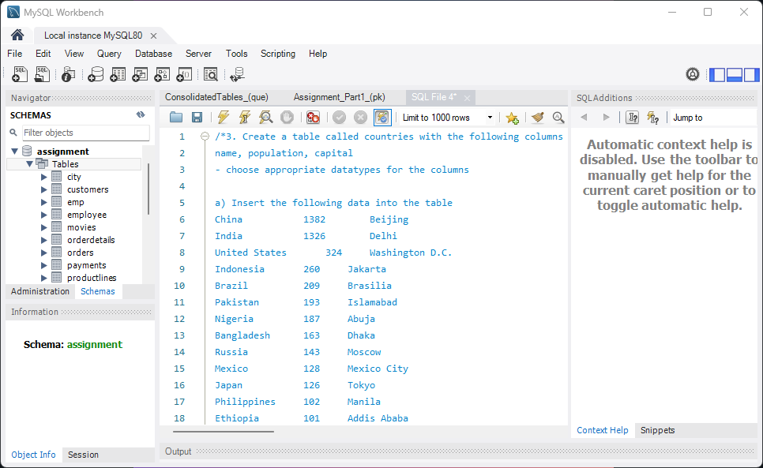

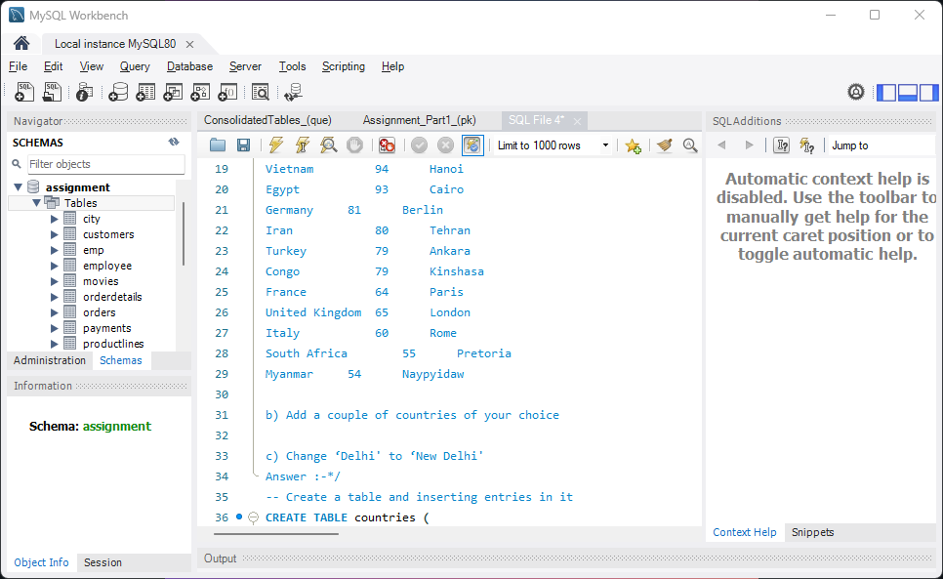

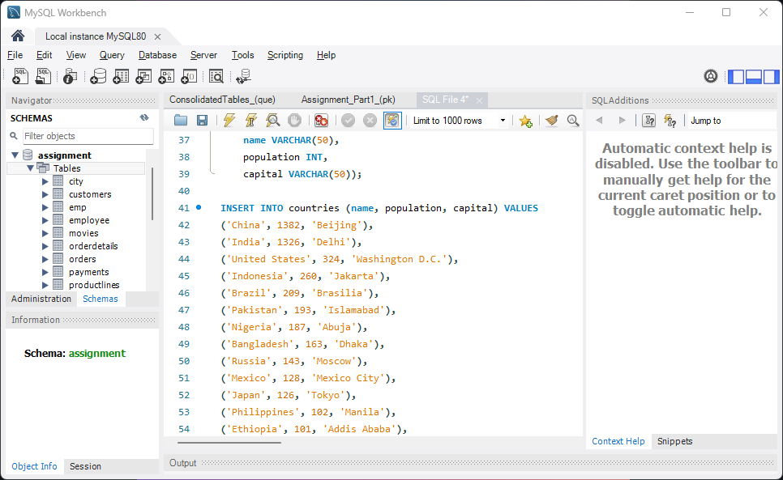

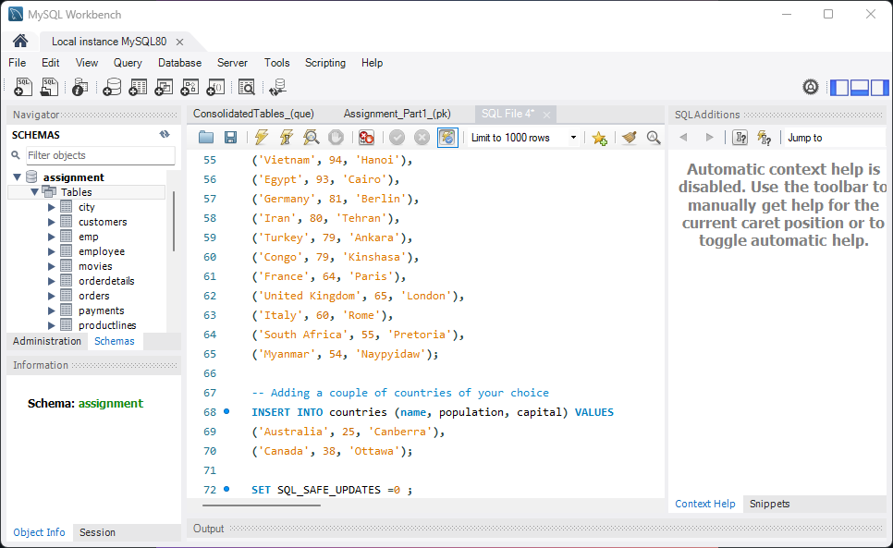

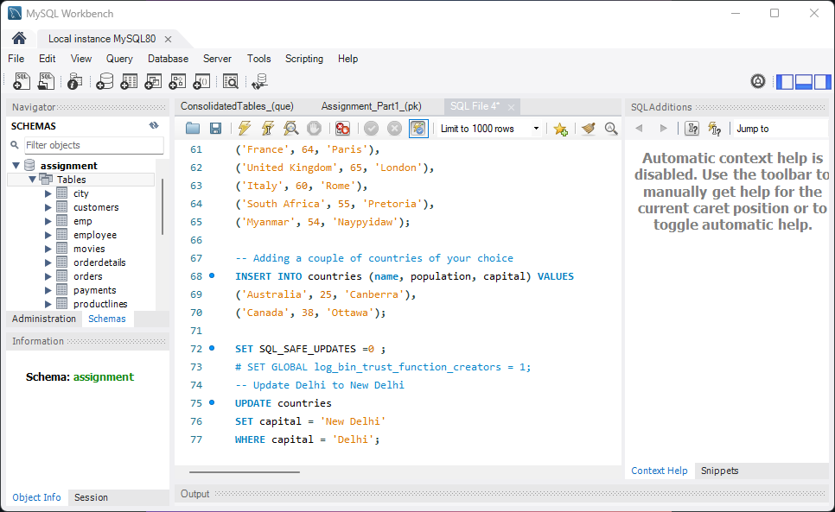

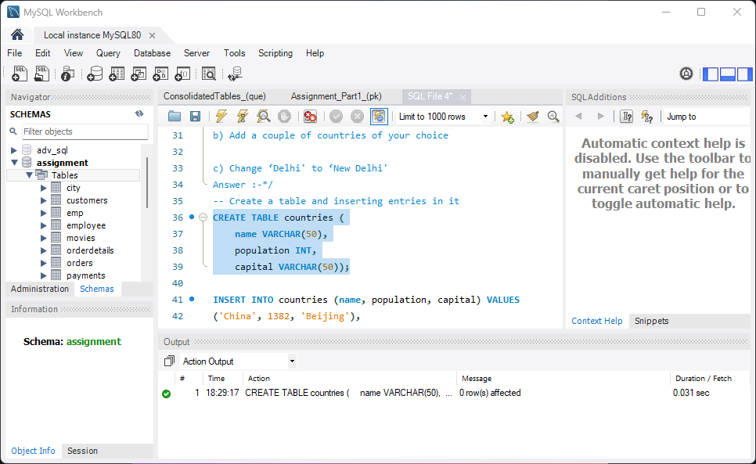

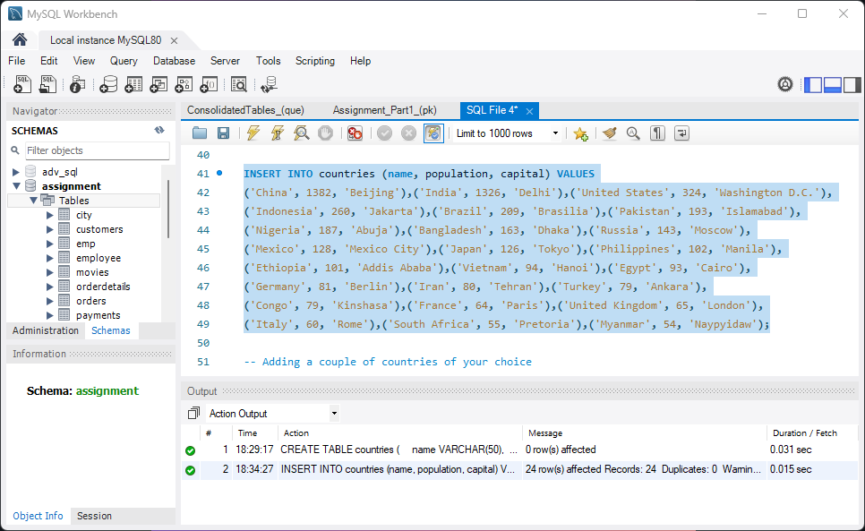

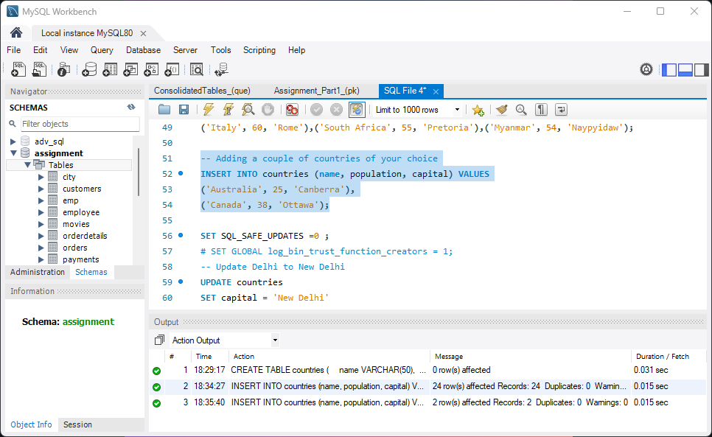

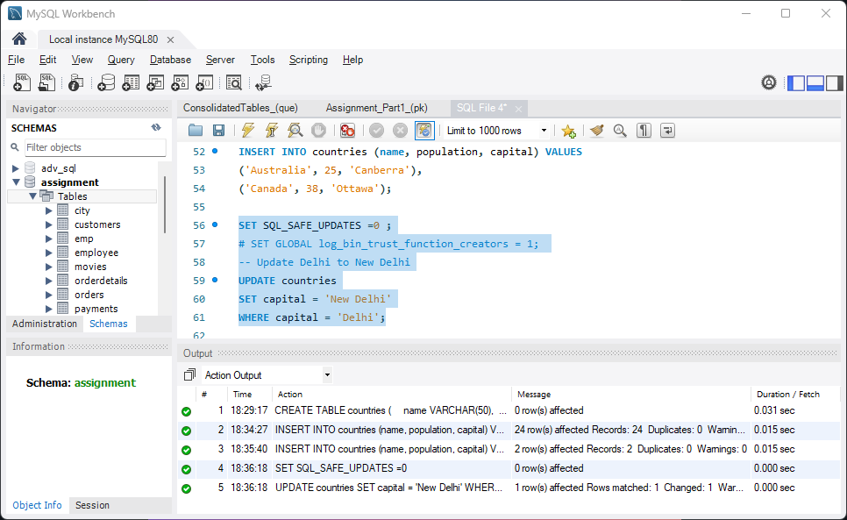

4. Rename the table countries to big_countries .

**Answer :-**

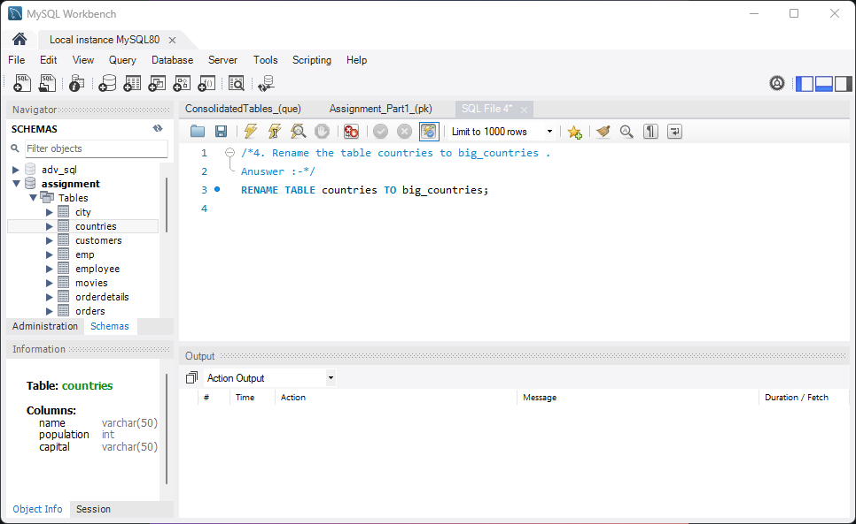

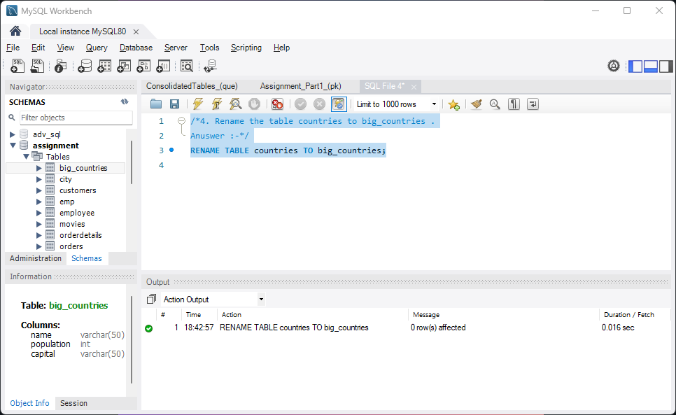

5. Create the following tables. Use auto increment wherever applicable

a. Product

product_id - primary key

product_name - cannot be null and only unique values are allowed

description

supplier_id - foreign key of supplier table

b. Suppliers

supplier_id - primary key

supplier_name

location

c. Stock

id - primary key

product_id - foreign key of product table

balance_stock

**Answer :-**

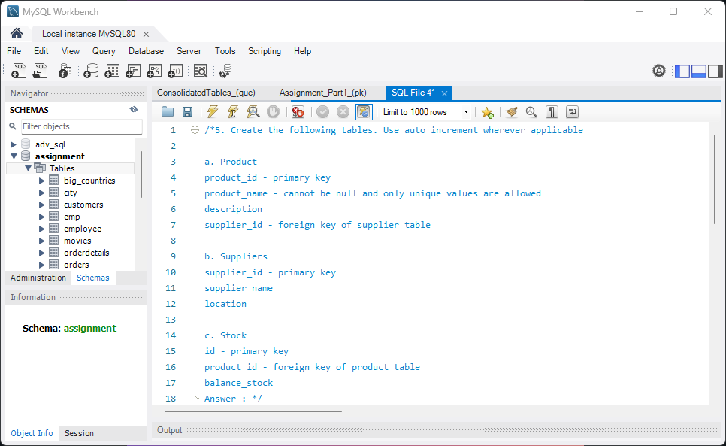

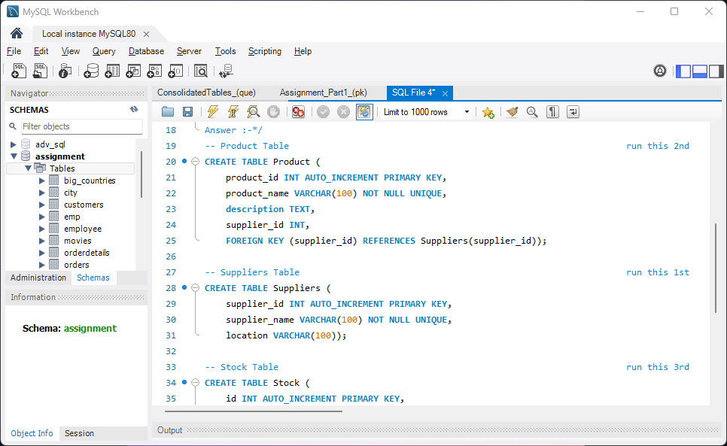

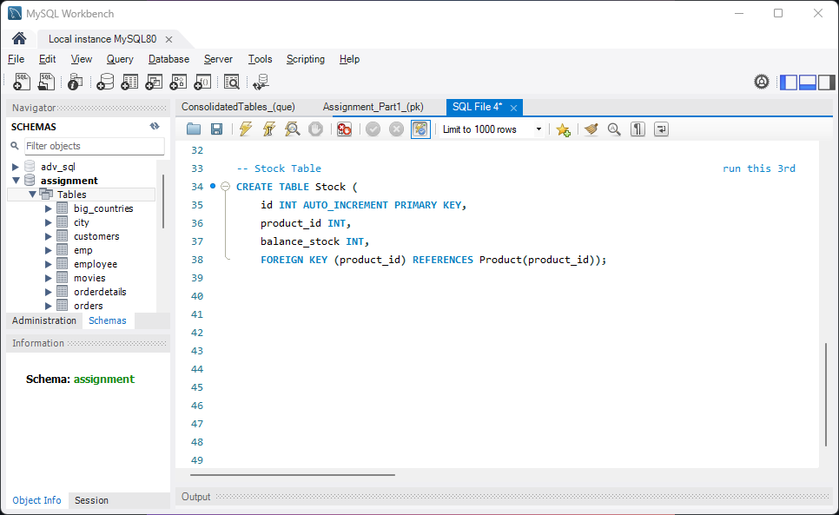

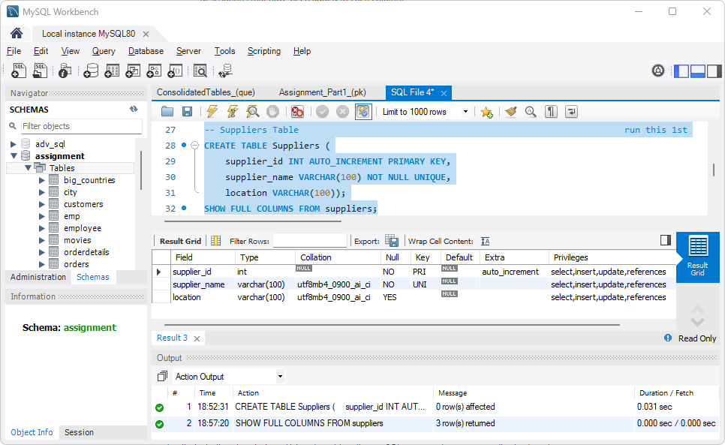

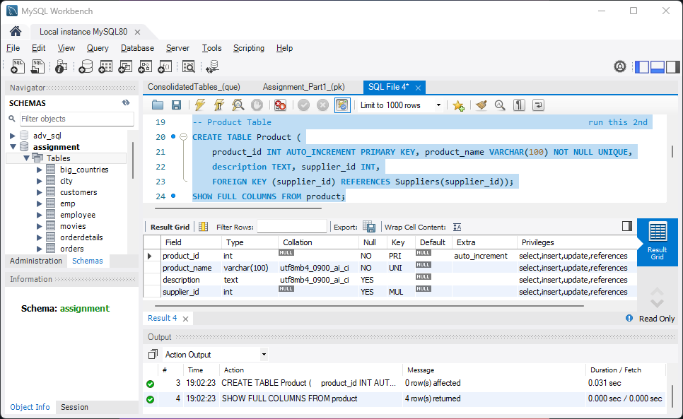

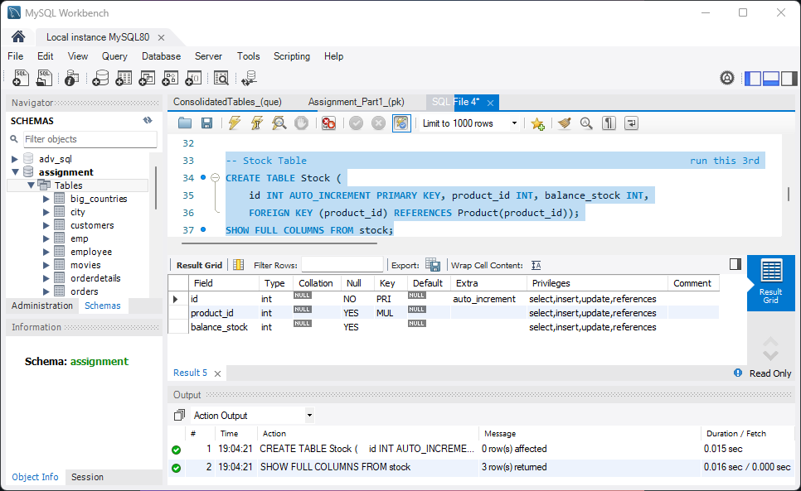

6. Enter some records into the three tables.

**Answer :-**

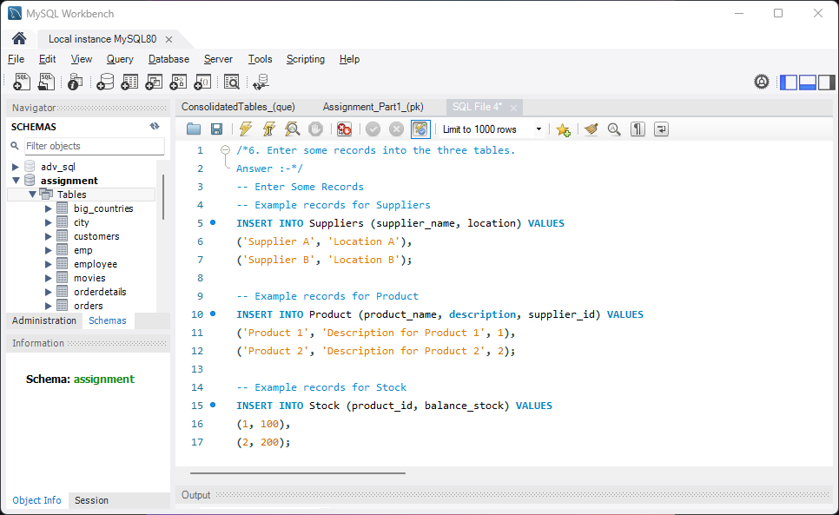

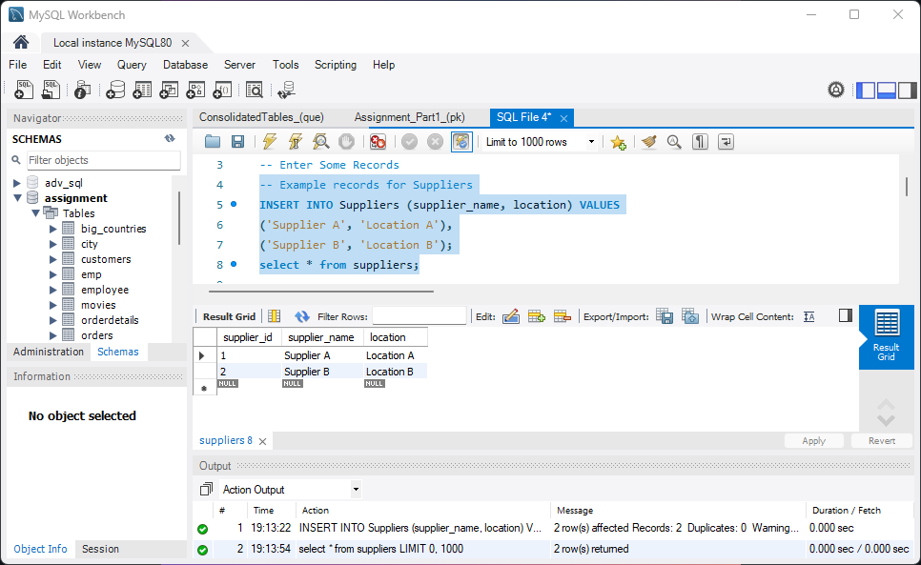

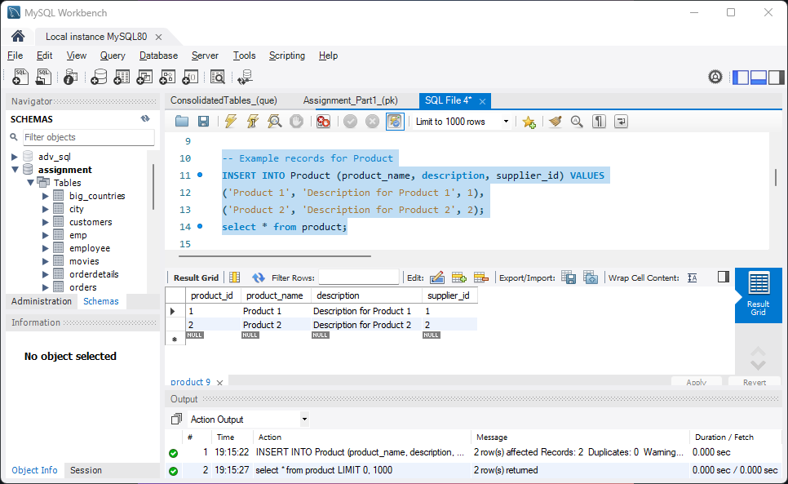

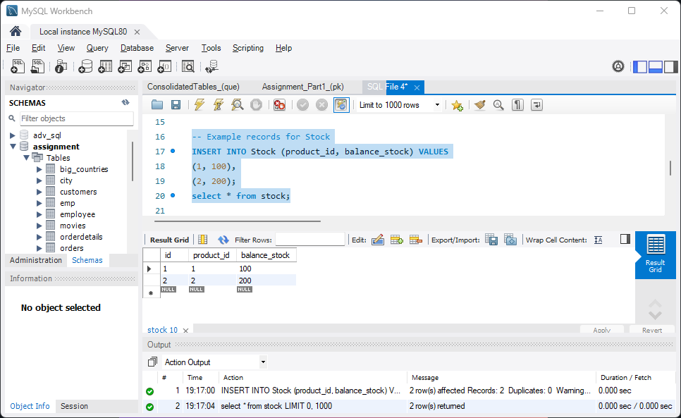

7. Modify the supplier table to make supplier name unique and not null.

**Answer :-**

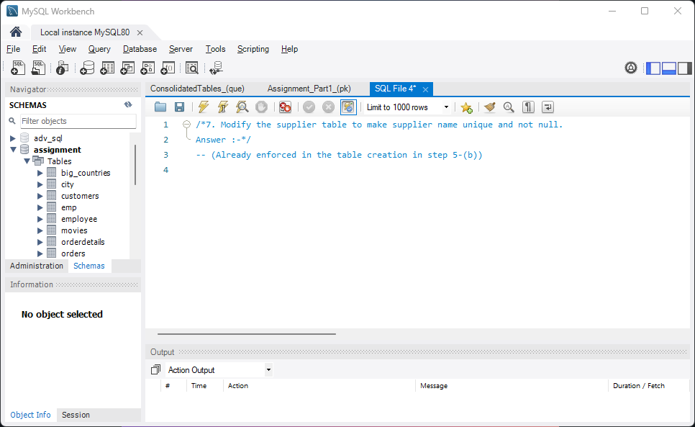

8. Modify the emp table as follows

1. Add a column called deptno

b. Set the value of deptno in the following order

deptno = 20 where emp_id is divisible by 2

deptno = 30 where emp_id is divisible by 3

deptno = 40 where emp_id is divisible by 4

deptno = 50 where emp_id is divisible by 5

deptno = 10 for the remaining records.

**Answer :-**

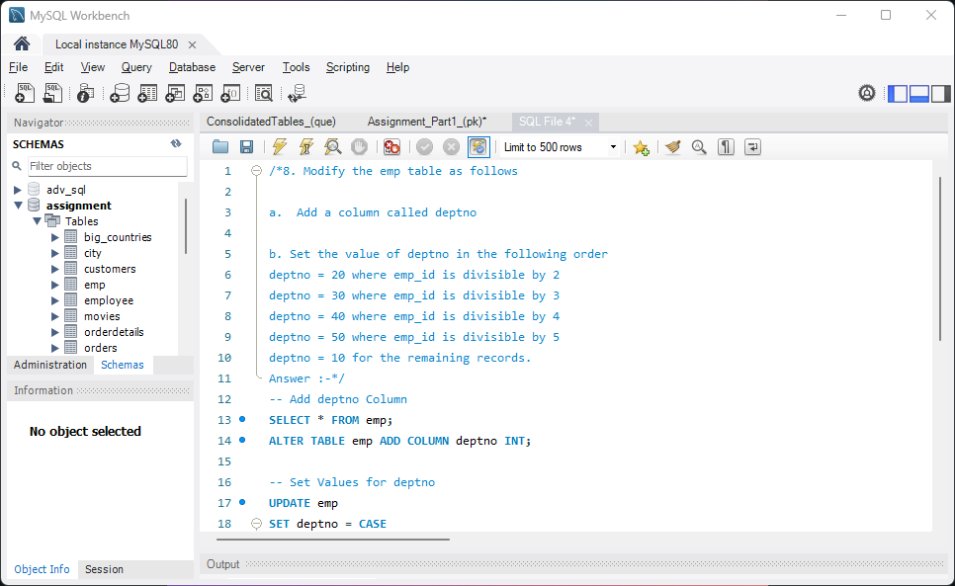

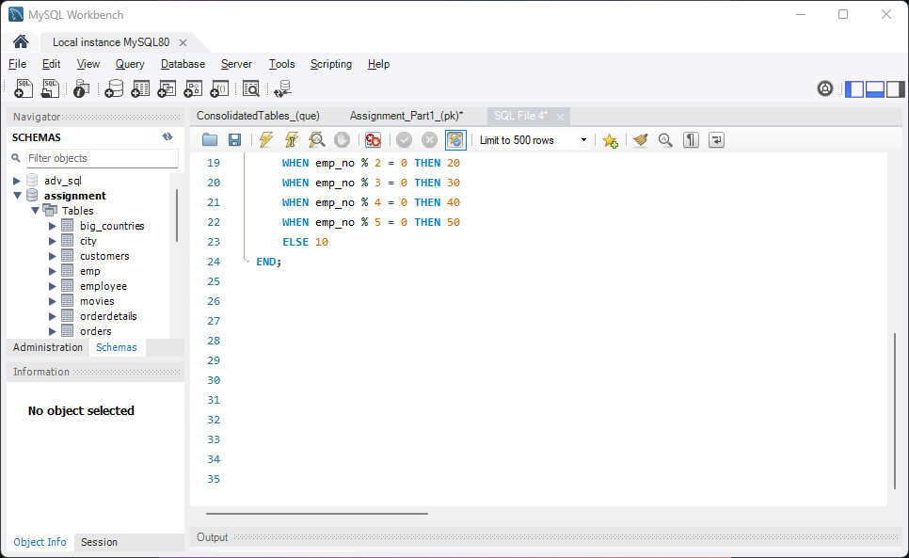

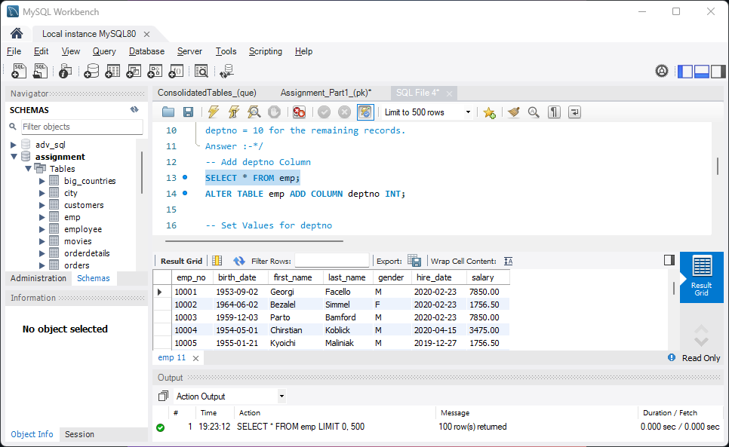

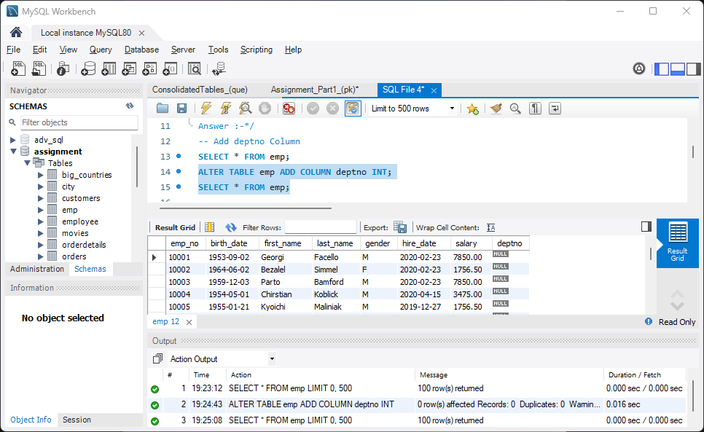

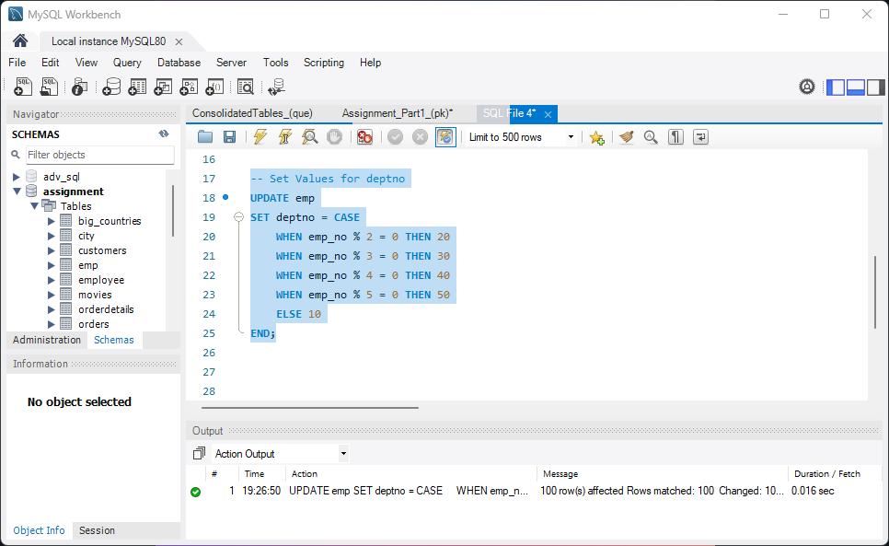

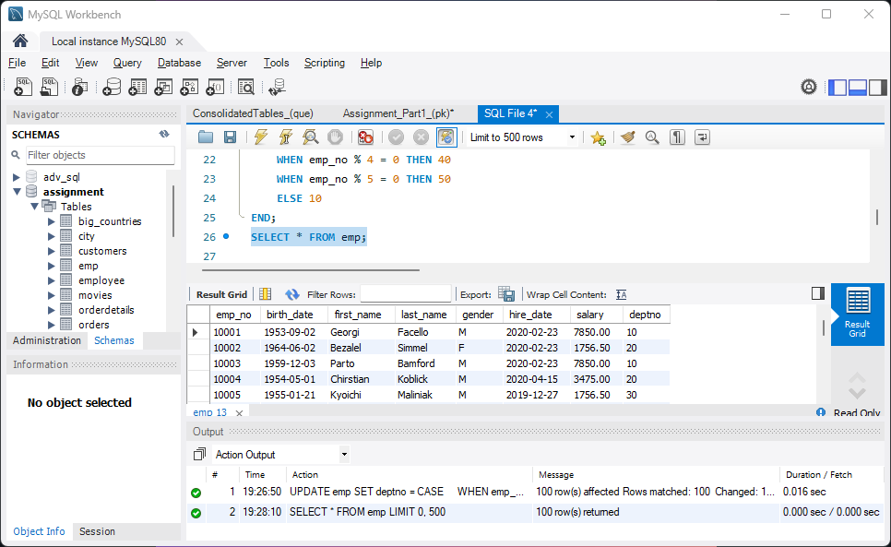

9. Create a unique index on the emp_id column.

**Answer :-**

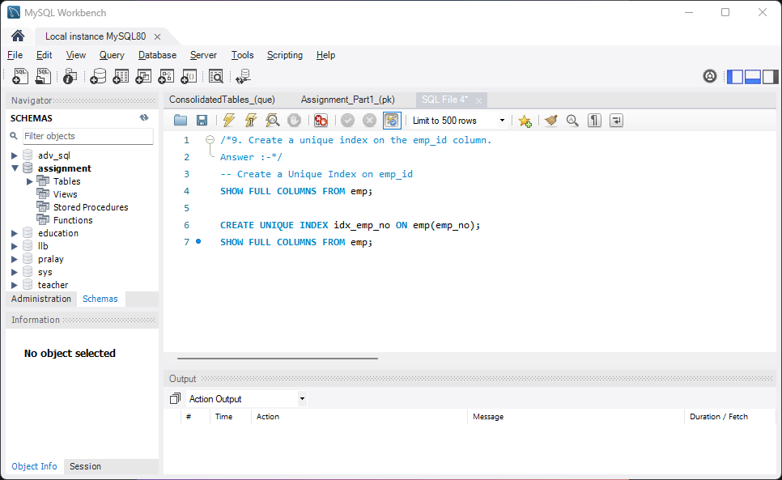

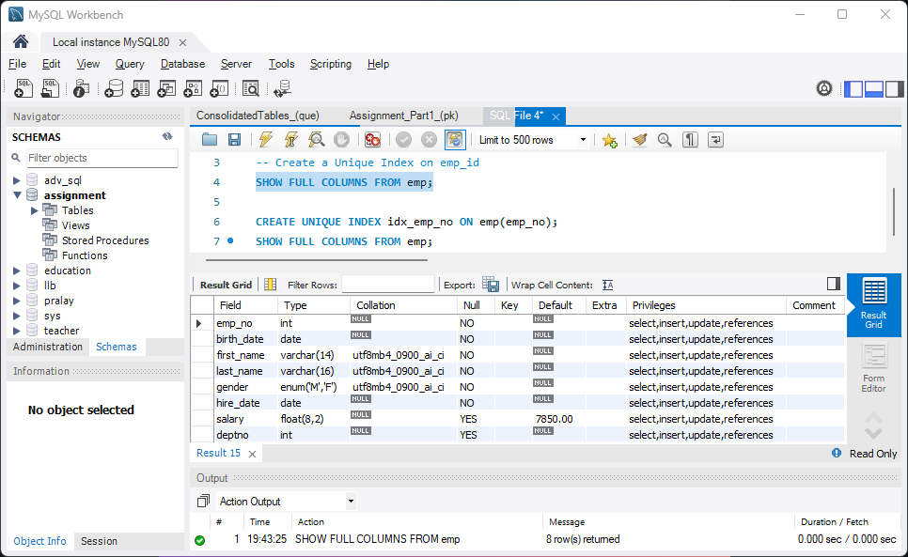

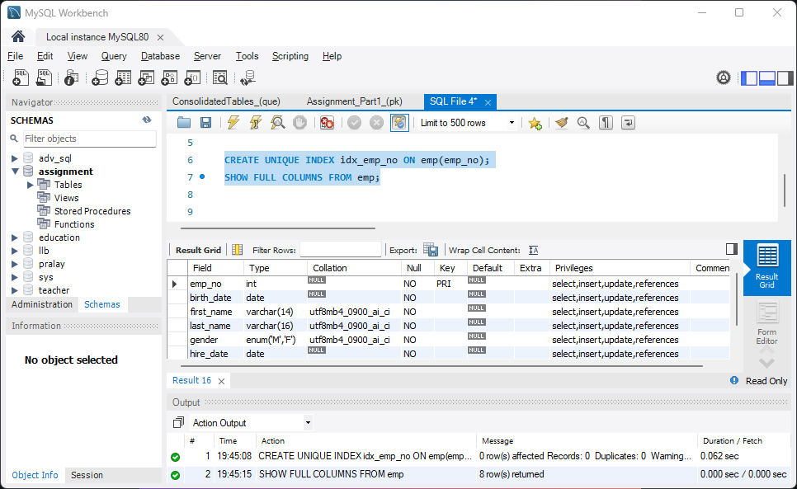

10. Create a view called ***emp_sal*** on the **emp** table by selecting the following fields in the order of highest salary to the lowest salary.

emp_no, first_name, last_name, salary

**Answer :-**

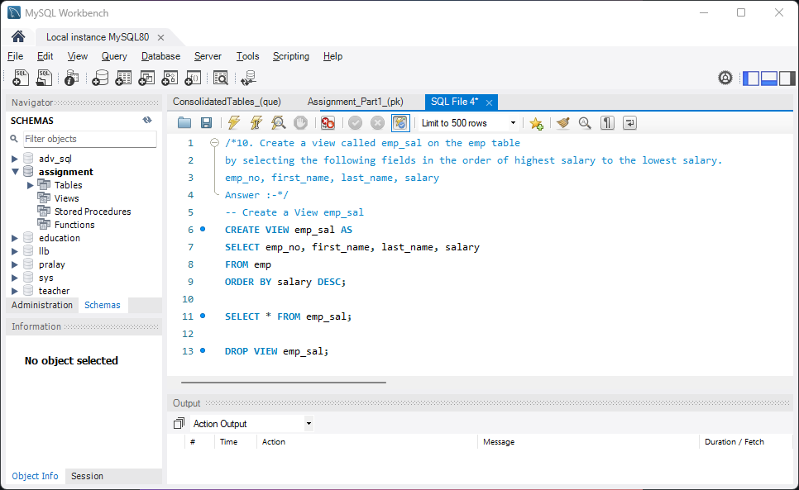

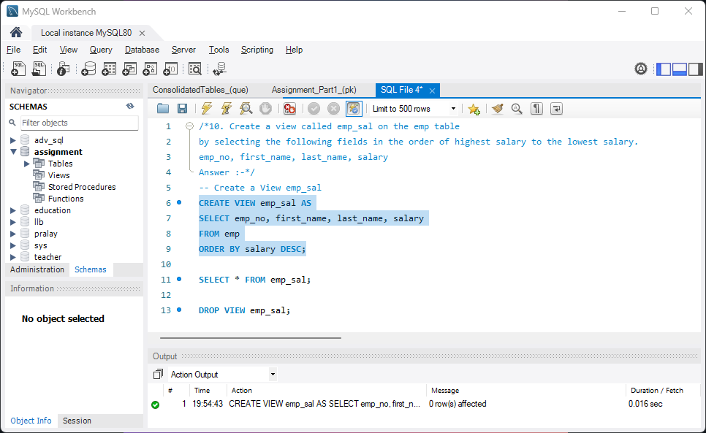

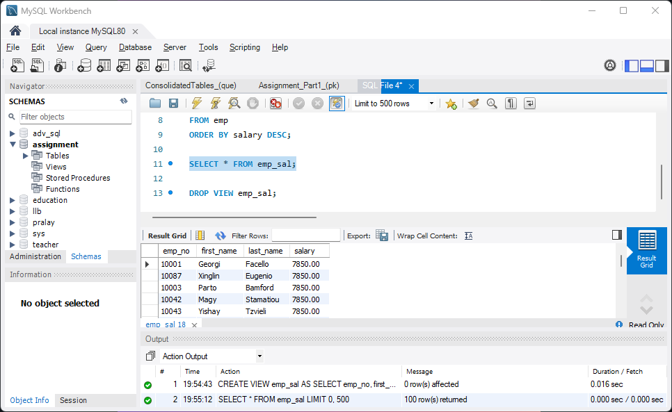

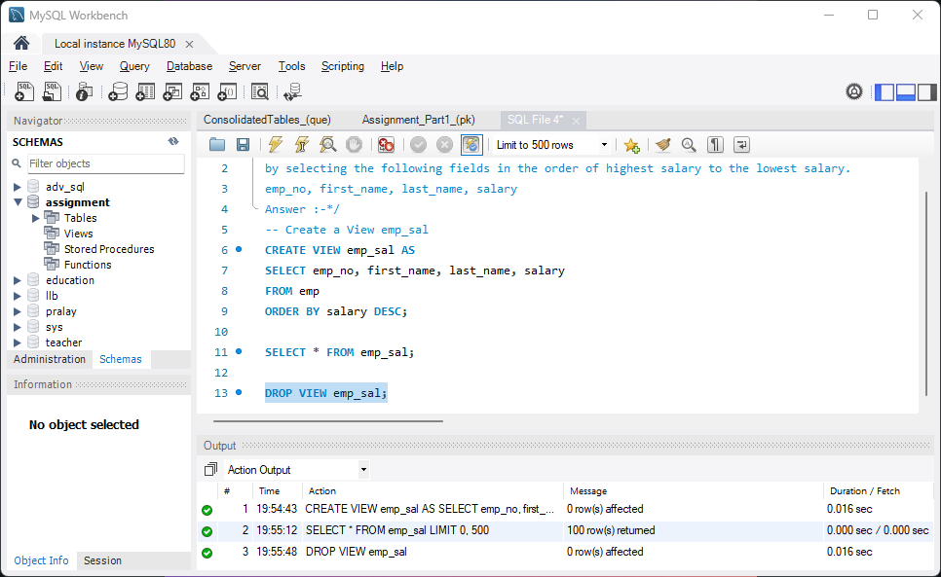

END.